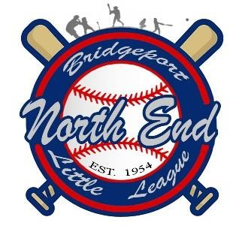
North End Little League _{Office Use}
A Chartered League Since 1954 Division____________
2024 Player Application Rec’d App_______

___________________________________________________________________________________________
Player’s Full Name

Male______ Female______ ______/____/_____ Shirt Size________ Pants Size_______
Date of Birth

______________________________________________/________________________/_________________________
Street Address City Zip Code

Parent/Guardian #1: Name__________________________________________ Phone #___________________________

Email: _________________________________________________________________

Parent/Guardian #2 Name__________________________________________ Phone #___________________________

Email: _________________________________________________________________

How did you hear about our registration dates? (Facebook, Friend, Lawn Sign, etc.): _______________________________
-------------------------------------------------------------------------------------------------------------------------------------------------------
LEAGUE USE ONLY

Returning Player? YES or NO Division: _________________ Team: ___________________

Date of Birth: _____________________ 2024 League Age: _________ (see League Age Chart)

Does this child play any other teamed sport during the little league season? _____________________________________

2024 Divisions: Tball Coach Pitch Minors Major Intermediate
Ages: 4*-6 7-8 9-10 10-12 13
Fees: $120 ** $120** $160** 160** 180**
($10 Multi-Player Discount up to a total of $20 max per Family)
* As long as a Parent or Guardian Volunteer to Coach the 4-year-old child can play
** A $40 non-refundable fee (by selling fundraiser tickets) in addition to a $3.00 processing fee from Sports Connect to the price
Note: Minor, Major, and Intermediate Divisions will have patched umpires
Type of payment: Cash $______________ (give cash receipt)

*Check #_________ Name on check_______________________________ (make copy of check for file)

Credit Card________ (attach league receipt to this form)

* A $30 charge will be charged for returned checks.

Little League Baseball does not limit participation in its activities based on disability, race, color, creed, national origin, gender, sexual preference, or religious preference. LEAGUE ID #02070203
nellbridgeport@yahoo.com * www.nellbpt.com * www.facebook.com/NELLBPT

